C2. Power Transmission (Hard Edition)
time limit per test
3 seconds
memory limit per test
256 megabytes
input
standard input
output
standard output
This problem is same as the previous one, but has larger constraints.
It was a Sunday morning when the three friends Selena, Shiro and Katie decided to have a trip to the nearby power station (do not try this at home). After arriving at the power station, the cats got impressed with a large power transmission system consisting of many chimneys, electric poles, and wires. Since they are cats, they found those things gigantic.
At the entrance of the station, there is a map describing the complicated wiring system. Selena is the best at math among three friends. He decided to draw the map on the Cartesian plane. Each pole is now a point at some coordinates (xi,yi)(xi,yi). Since every pole is different, all of the points representing these poles are distinct. Also, every two poles are connected with each other by wires. A wire is a straight line on the plane infinite in both directions. If there are more than two poles lying on the same line, they are connected by a single common wire.
Selena thinks, that whenever two different electric wires intersect, they may interfere with each other and cause damage. So he wonders, how many pairs are intersecting? Could you help him with this problem?
Input
The first line contains a single integer nn (2≤n≤10002≤n≤1000) — the number of electric poles.
Each of the following nn lines contains two integers xixi, yiyi (−104≤xi,yi≤104−104≤xi,yi≤104) — the coordinates of the poles.
It is guaranteed that all of these nn points are distinct.
Output
Print a single integer — the number of pairs of wires that are intersecting.
Examples
input
Copy
4
0 0
1 1
0 3
1 2
output
Copy
14
input
Copy
4
0 0
0 2
0 4
2 0
output
Copy
6
input
Copy
3
-1 -1
1 0
3 1
output
Copy
0
Note
In the first example:
In the second example:
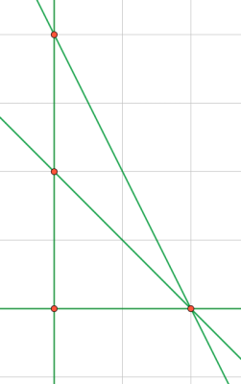
Note that the three poles (0,0)(0,0), (0,2)(0,2) and (0,4)(0,4) are connected by a single wire.
In the third example:
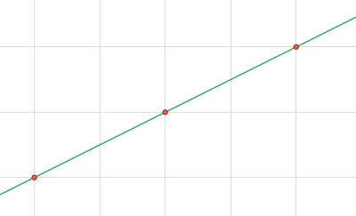
总想着叉乘。。还否认了我那么接近正解的那一刻的想法。
就是对于每条直线，计算斜率和c。用斜率来当map的头， c当mp的映射
c相同就是同一条直线。。不相同就是不是。
然后答案只要记录不跟他平行的直线数量就可以了
First, we will divide the problem into several parts: 1) construct the wires, 2) remove duplicates, and 3) count the number of pairs that intersect.
The first part is relatively simple: note that each wire is simply a line that goes through two distinct points (poles) on the OxyOxy plane. Suppose this line goes through point A(x1,y1)A(x1,y1) and point B(x2,y2)B(x2,y2), then it can be described by the equation ax−by=cax−by=c where a=y1−y2a=y1−y2, b=x1−x2b=x1−x2, c=y1x2−y2x1c=y1x2−y2x1.
For step two, we will simplify the equation for each line by dividing each coefficient by their greatest common divisor. Now each equation uniquely identifies a line, and vice versa - so we can sort the wires by their values of a, b, and c; then remove adjacent duplicates.
The final part of the solution also makes use of this sorted list. As any pair of lines on the plane must intersect unless they are parallel, we only need to count the number of parallel pairs and subtract these from the total number of pairs. These are the pairs with the same slope (i.e. same value of a and b), and they already are next to each other in our list. We now iterate over these "blocks" of parallel lines and count the number of pairs each block contributes — a block of size ss gives s(s−1)2s(s−1)2 pairs.
Complexity: O(n2logn)O(n2log⁡n).

#include <cstdio>#include <map>#include <set>#include <utility>const int N = 1001;int x[N], y[N];
std::map<std::pair<int,int>,std::set<long long>> slope_map;
int gcd(int a, int b) {
if (a == 0)
return b;
return gcd(b % a, a);}
int main(){
int n; scanf("%d", &n);
for (int i = 1; i <= n; ++i)
scanf("%d%d", &x[i], &y[i]);
long long total = 0, res = 0;
for (int i = 1; i <= n - 1; ++i)
for (int j = i + 1; j <= n; ++j)
{
int x1 = x[i], y1 = y[i], x2 = x[j], y2 = y[j];
// construct a line passing through (x1, y1) and (x2, y2)
// line is expressed as equation ax - by = c with constant a, b, c
int a = y1 - y2, b = x1 - x2;
// simplify equation
int d = gcd(a, b); a /= d, b /= d;
if (a < 0 || (a == 0 && b < 0))
{
a = -a;
b = -b;
}
// lines with the same slope (same a, b) are stored in a map
std::pair<int,int> slope(a, b);
long long c = 1LL * a * x1 - 1LL * b * y1;
if (!slope_map[slope].count(c))
{
++total;
slope_map[slope].insert(c);
// if this line is new, it intersects every line with different slope
res += total - slope_map[slope].size();
}
}
printf("%lld\n", res);}

